16.265 Logic Design Laboratory Grade Sheet

This page should be stapled together with the rest of the report. After the grading, this page will be taken and kept by the TAs for the record. .

- (This section to be completed by student)

Student logic number: 117
Student name: (Last) ________E___________, (first) _____Erdun____________________
Experiment number: 4
Date/time: ___04__/__18___/ ___2018____, _____10_____a.m..
- Preliminary checking
- Is the report written on 8½” x 11” paper and stapled at left margin?
- Is a cover page included?
- Is the report written using the given template?
- Is the correct assignment used in design?

Report will not be accepted if the answer is “NO” to any of the above questions.

- Grade
Design using D flip-flops
1. Design procedures: supporting theory, details, etc. (10) ___________
2. Is design correct? (25) ___________
3. Minimization of design (10) ___________
4. List of ICs and unused gates (5) ___________
Design using JK flip-flops
1. Design procedures: supporting theory, details, etc. (10) ___________
2. Is design correct? (25) ___________
3. Minimization of design (10) ___________
4. List of ICs and unused gates (5) ___________
Gross grade (100) __________
- Adjustment to grade
1. Grade sheet, cover page (−5) ___________
2. Title box of schematic diagram (−5) ___________
3. Schematic diagram in correct format (−10) ___________
4. Misrepresentation of test (simulation) results (−30) ___________
- 5. Neatness and legibility (−10) __________
- 6. Templates (−20) __________
Final grade (100) __________
Comments: ___________________________________________________________________________
_____________________________________________________________________________________

Grader: _________________________ Date: ____/____/________

16.265 Logic Design
Student Logic Number | 117
Name | Erdun e
E-mail address (print) | Erdun_E@student.uml.edu
Experiment Number | 4
Date | 04-18-2018

For grader use
Schematic diagram submitted is different from the one in the report. (Need to re-submit the schematic diagram in the report or will be graded based on a maximum of 50 points.) | 5 points deduction
Cannot open file
File is not readable

Date student is notified to re-submit a schematic file by e-mail
Date schematic file received

Report will be graded based on a maximum of 50 (out of 100 points) if a schematic diagram is not received within three calendar days of notification or the re-submitted schematic file still cannot be opened or is not readable.

Grade: ___________
Experiment 4 Six-State Up-Down Counter

1. Sequence assignment

RESET
1
1
1
1
1
1
0
0
0
0
0
0

2. Next-state maps

Construction of transition table

Present state  Q₂ Q₁ Q₀ | Next state Q⁺₂ Q⁺₁ Q⁺₀
Present state  Q₂ Q₁ Q₀ | C = 0 | C = 1
0 0 0
0 0 1
0 1 0
0 1 1
1 0 0
1 0 1
1 1 0
1 1 1

Convert the transition table to next-state maps.
00
Q₂Q₁
01
11
10
CQ₀
00
01
11
10
Q₁⁺
00
Q₂Q₁
01
11
10
CQ₀
00
01
11
10
Q₀⁺
00
Q₂Q₁
01
11
10
CQ₀
00
01
11
10
Q₂⁺

3. Design using D flip-flops
00
Q₂Q₁
01
11
10
CQ₀
00
01
11
10
D₁
00
Q₂Q₁
01
11
10
CQ₀
00
01
11
10
D₀
00
Q₂Q₁
01
11
10
CQ₀
00
01
11
10
D₂

Determine the excitation functions from the next state maps.
D₂ =
D₁ =
D₀ =

List of ICs and unused gates for design using D flip-flops

IC number | Type number | Function | Unused gates
1 | 7474 | Dual D type flip-flops | None
2 | 7474 | Dual D type flip-flops | 1 D flip-flop
3
4
5
6
7
8

Simulation results for design using D flip-flops
Unused states
C = 0
Unused states
C = 1

Draw the schematic diagrams for the counter using D flip-flops.
Insert a complete schematic diagram including the title box.
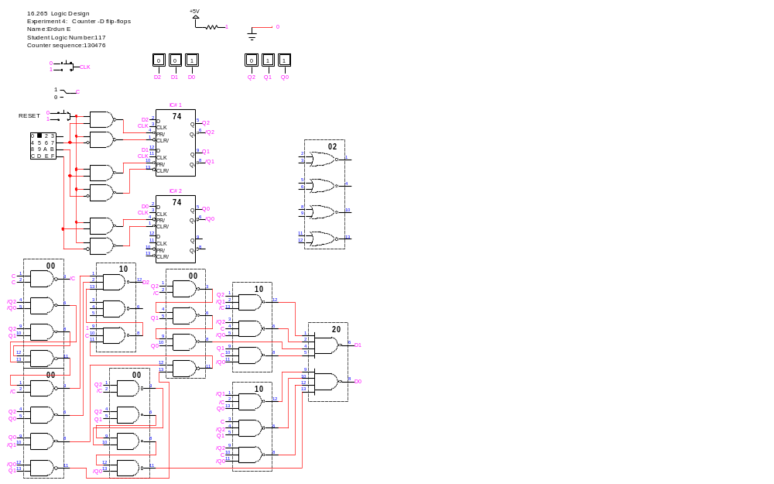

4. Design using JK flip-flops

00
Q₂Q₁
01
11
10
CQ₀
00
01
11
10
Q₁⁺
00
Q₂Q₁
01
11
10
CQ₀
00
01
11
10
Q₀⁺
00
Q₂Q₁
01
11
10
CQ₀
00
01
11
10
Q₂⁺

Partition the next state maps into K-maps for the excitation functions.
(Don’t forget to label the variables at the upper left corner of each K-map.)

00
01
11
10
0
1
J₂
00
01
11
10
0
1
K₂
00
01
11
10
0
1
J₁
00
01
11
10
0
1
K₁
00
01
11
10
0
1
J₀
00
01
11
10
0
1
K₀

Determine the excitation functions from the six K-maps.

J₂ = K₂ =
J₁ = K₁ =
J₀ = K₀ =

List of ICs and unused gates for design using JK flip-flops

IC number | Type number | Function | Unused gates
1 | 7476 | Dual JK type flip-flops | None
2 | 7476 | Dual JK type flip-flops | 1 JK flip-flop
3
4
5
6
7
8

Simulation results for design using JK flip-flops
Unused states
C = 0
Unused states
C = 1
Draw the schematic diagrams for the counter using JK flip-flops.
Insert a complete schematic diagram including the title box.
